Mapping Scenario #13 – Multiple Misc School Records

Scenario: How do we handle with Misc school records (Example – warehouse, nutrition office, etc)? There are many odd records for K-12 segments. Some school district could have a warehouse or a separate office location for nutrition. Do we add them as “unit” records? Do we link them to the parent record?

Example: Vizient has several records like this. A few examples below:
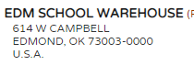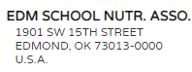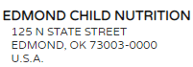

Solutions: PENDING

There are few scenarios for this which require some research. We still need to figure this out. As of right now, in a CHO account, we cannot have more than 1 record to be mapped to a 1FS parent record. I see we have two options:

A - Change the logic to allow 2 or more records link to a parent record

B- Create an “unit” record to link all misc records and name the record “Edmond Public Schools - Admin Offices” and link to the parent (school district)

