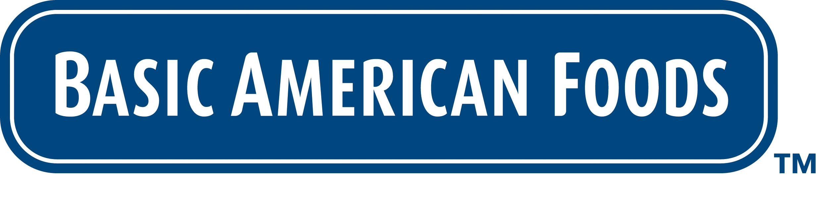

PRESS RELEASE

Introducing Potato Pearls® EXCEL® Original Butter Mashed – Reduced Sodium: The same butter flavor you love, now with 50% less sodium

DATE – Walnut Creek, CA: Basic American Foods (BAF) knows that today’s foodservice operators need to menu lower sodium foods, that taste great. Introducing New EXCEL® Original Butter Mashed – Reduced Sodium, the most popular mashed potato, with the same great butter flavor and aroma your customers love, but with 50% less sodium.

With New EXCEL® Original Butter Mashed– Reduced Sodium you can deliver a consistent, delicious mashed you’re proud to serve and your patrons will love every time.

- Easy – just add water
- Best Value – low portion cost, highest servings per case and zero waste
- Delicious – 50% less sodium, 100% of the rich, butter flavor

With Basic American Foods you’re serving the sides your customers crave – at their easiest, most affordable and most delicious. But don’t take our word for it, to sample the buttery-rich taste of New EXCEL® Original Butter Mashed– Reduced Sodium go to www.baf.com/freesample

Making Your Best Sides Even Better
Family owned and operated since 1933, Basic American Foods is the leading supplier of dry potatoes and beans to the foodservice market. Our portfolio provides craveable comfort foods that are easy to prepare, delicious to eat and best meet the demands of foodservice kitchens. That means you are able to deliver consistent, quality sides you are proud to serve and your patrons love, every time.

###

