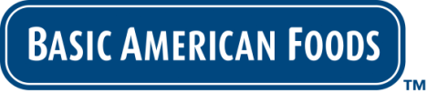
FOR IMMEDIATE RELEASE

Contact: Tanya Benson-Smith
Basic American Foods
tbenson@baf.com

Add Variety to Your Menu With Brilliant Beginnings™ Recipe-Ready Mashed Potatoes from Basic American Foods

Mashed potatoes are the perfect side dish for almost any meal and one of America’s favorite comfort foods. Now you can prepare them in minutes using Brilliant Beginnings™ Recipe-Ready Mashed Potatoes, the latest offering from Basic American Foods, the recognized industry leader in shelf-stable dried potato products.

Brilliant Beginnings™ Recipe-Ready Mashed Potatoes are made from fresh, USA-grown Idaho Russet potatoes that are harvested at their peak flavor. After being washed and peeled, they are slowly cooked, riced, and carefully dried to maintain the authentic texture and flavor of fresh potatoes, without the addition of artificial flavors or colors.

Our quick, easy three-step preparation process saves you time, labor and money. Simply add water and your own signature ingredients to create delicious custom side dishes – the possibilities are nearly endless:

Roasted Garlic and Buttermilk Mashed Potatoes – Creamy mashed potatoes mixed with roasted garlic, chives and fresh buttermilk. A classic accompaniment for grilled meats and fish.

Parmesan Herb Gnocchi – Homemade pasta has never been easier; simply add fresh whole eggs, flour, grated Parmesan and minced chives to create this classic Italian dish that can be topped with your favorite sauce.

Visit the Basic American Foods website at baf.com for more flavorful side dish recipes using Brilliant Beginnings™ Recipe-Ready Mashed Potatoes.

Family owned and operated since 1933, Basic American Foods is a global leader in providing value-added, branded dry potato and bean products to foodservice. Its principal brands delivering preparation convenience with scratch-like taste include Potato Pearls®, Golden Grill®, Classic Casserole® and Santiago®.

###

